Software Requirements Specification
for
QUIZ APPLICATION
Version 1.0 approved
Prepared by:
Ajay T Shaju – 04
Judin Augustine – 45
Justin Thomas Jo - 46
Noyal Joseph - 49
Vishnuprasad KG - 63
Mentor:
Prof. Jabin Mathew
Date:
6th January 2023
Table of Contents
Table of Contents ii
1. Introduction 1
1.1 Purpose 1
1.2 Document Conventions 1
1.3 Intended Audience and Reading Suggestions 1
1.4 Product Scope 1
1.5 References 1
2. Overall Description 2
2.1 Product Perspective 2
2.2 Product Functions 2
2.3 User Classes and Characteristics 2
2.4 Design and Implementation Constraints 3
2.5 User Documentation 3
2.6 Assumptions and Dependencies 3
3. External Interface Requirements 3
3.1 User Interfaces 3
3.2 Hardware Interfaces 3
3.3 Software Interfaces 3
3.4 Communications Interfaces 4
4. System Features 4
4.1 The System - Quiz Application 4
4.2 Admin Panel 4
4.3 Question Controls 4
4.4 User Controls 4
4.5 User Panel 4
5. Other Nonfunctional Requirements 5
5.1 Performance Requirements 5
5.2 Safety Requirements 5
5.3 Security Requirements 5
5.4 Software Quality Attributes 5
5.5 Business Rules 5
Appendix A: Glossary 6
Appendix B: Group Log 6

Introduction

Purpose

The main purpose of this document is to provide the Software Requirements Specification (SRS) for developing a Quiz Application. It will explain the purpose and features of the entire system and how it will function according to various user’s needs. The application will help the users to challenge themselves and gain knowledge.

Document Conventions
This Document was created based on the IEEE template for System Requirement Specification
Documents.

Intended Audience and Reading Suggestions
This SRS document is intended for programming developers, product testers, project managers,
marketing staff; and our stakeholders may review as a guideline for understanding the requirements
and maintain the main goal of the application. By reading this document, the reader will get a
general understanding of the product including the application’s functional and non-functional
requirements.

Product Scope
The application aims providing a personal challenge to answer some standard questions in separate categories thereby checking the knowledge levels. Currently, some quiz application exists, but most of them are clutter with information and makes it difficult for a user to play some quiz. Our application provides a minimal system with very relevant options on which the user can select category and attend quiz as fast as possible. This application will be free and easy to use for everyone who need to boost their brain.

References
- https://www.geeksforgeeks.org/python-gui-tkinter/
- https://dev.mysql.com/doc/connector-python/en/
- https://stackoverflow.com/questions/tagged/tkinter
- https://stackoverflow.com/questions/tagged/mysql
- https://www.tutorialspoint.com/
- https://www.javatpoint.com/
- https://www.youtube.com/c/Codemycom

Overall Description

Product Perspective
This quiz application is developed to provide an interactive and engaging platform for users to challenge themselves and gain knowledge on various topics. The application allows users to log in and take quizzes on various categories provided. The application's user-friendly interface and comprehensive feature-set make it a valuable tool for anyone looking to learn and test their knowledge.

Product Functions
- User authentication: Users can create accounts, log in to the application, and reset their passwords if they forget it.
- Quiz creation: Admins can create and publish categories and questions. This could include adding multiple choice, and specifying the categories the quiz belongs to.
- Quiz taking: Users can take quizzes and receive immediate report on their performance. The application will record the user's activity while attending the quiz.

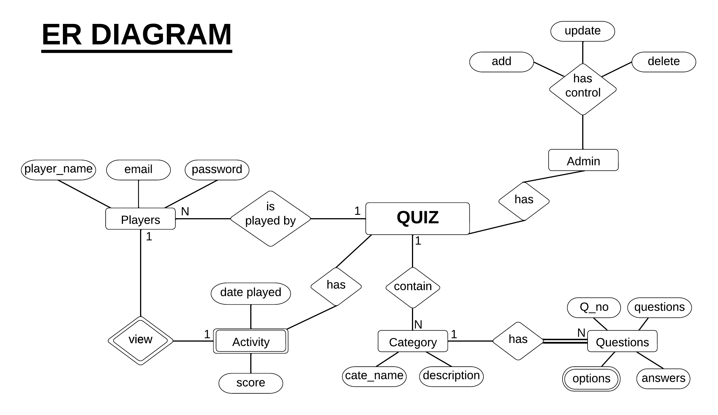
User Classes and Characteristics

Administrator:
• Managing the quiz platform, add/delete quiz items.
• Managing user accounts.
• Monitoring platform activity.

Users:
• Users take quizzes and track their progress on the platform.
• Users are able to create accounts, log in to the application, and update their personal information.

Design and Implementation Constraints
- Data security: All user data, including quiz performance and personal information, must be protected and secure.
- Scalability: The application should be designed to accommodate future changes and updates, including the addition of quiz recommendation or payment methods.
- User experience: The application should be user-friendly and easy to navigate, with a clean and intuitive interface.

User Documentation
- To help users get the most out of the quiz application, a user manual will be provided. This manual will include step-by-step instructions on how to use various features.
- If users have any additional questions or need further assistance, they can contact the support team via email for online help.
- The goal of this documentation is to make the application as user-friendly as possible and ensure that users are able to take full advantage of its features

Assumptions and Dependencies
It is assumed that the user will have a good working laptop with low latency wired/wireless mouse and keyboard.

External Interface Requirements

User Interfaces
The user interface is designed in Figma. The developer will have to learn about the functioning of the above software 'QUIZ APP' and the concepts of designing and UI. It incorporates with effective GUI concepts and focuses on user-friendly systems. It has good, appealing, and attractive interfaces with optimum hyperlink to select the required process.

Hardware Interfaces
- Minimum 4GB RAM
- Processor: i3 or similar type processor
- Graphics card not necessary

Software Interfaces
- The software is developed for computer use only
- The Frontend: Python Tkinter
- Interfacing with several modules in order to perform various operations in it
- The Backend: MySQL
- Require database connectivity to store and fetch values for various operation

Communications Interfaces
- No need of internet to use the app
- Can report to admin in case of any error
- Real time or dynamic service should be given in case of all changes appearing in the system.

System Features

This application contains the following system features:

The System – Quiz Application
User can attend quiz using the app. Admin can input new questions based on categories. Quiz is a proven way to retain information. Quiz is based ono categories so that it’s easier for the user to focus on topic at a time.

Admin Panel
Admin Panel provides you with various controls over users and question. It also gives you an overview of the users and questions. It provides all the functionality for an admin. It uses a separate login and password to access this page.

Question Controls
It provides various question controls including addition, updating and deletion.

User Controls
It provides various controls over users including add, update and delete.

User Panel
User panel provides a quick summary of the user. It shows details about the recent games, join date, an option edit profile and to start a game. It acts as a homepage for the users.

Other Nonfunctional Requirements

Performance Requirements
- Internal information of the categories and questions should only be accessible to the administrator.
- The application should be designed to cope up with the speed of the player.
- The modules of the quiz application should be accurately designed to smoothen the gameplay.
- Response time of the application should be minimal.
- User interface is expected to be as responsive as that of the application.

Safety Requirements
- In a special circumstance where the player has forgotten his/her login credentials, there will blue button provided for the player to reset the login credentials in the login page.
- Regular backups are done to prevent any data loss that may affect the integration of the program.
- Securing the information of users/players using security keys.

Security Requirements
- Only players who exist in the application database with proper authentication can play the quiz.
- Prevent any kind of communication inconsistency between sections of the system.
- Promises user privacy and safety of their credentials.

Software Quality Attributes
- Reliability: Assures that the quiz application gives the correct results consistently.
- Maintainability: Easy to maintain application, to add new code and bring modifications.
- Usability: Easy to use and learn how the application works.
- Security: Credentials of users are maintained by giving authentication to administrator and registered users only.
- Flexibility: The application keeps itself updated with every gameplay.
- Interoperability: The application of capable of working on different systems and platforms.
- Robustness: Promises an efficient working flow and adaptability.

Business Rules
- All regulations for design and development are met by this application.
- All reported issues are solved through agile user support and good communication.
- We assure that the users are comfortable with the application and have organized a feedback option for the user to give their inputs for improvement of the application.
Appendix A: Glossary
- UI: User Interface
- GUI: Graphical User Interface
Appendix B: Group Log
A group of five people has came together to make the Project. Many topics has came into discussions but 'Quiz App' feels like much useful directly for endusers. The topic and the group members’ names were then given to the instructor. All the five members then read the example SRS document provided. The Problem description, the purpose and the scope of the document was finalized. Each section was divided among the five members and each member was given the task to complete their sections with remotely using tools like Figma(for designs) and GitHub(for codes). The entire document was then clubbed to form the SRS for the Quiz Application.

